1. Create newfile using gedit



1. Save the following information in the file



1. Look into the file to see if its saved



1. Look for the string “nix”



Or

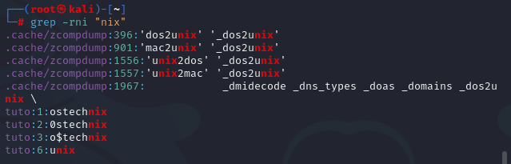

1. Search string has two words for example “hello world”



1. How to ignore case sensitive?



1. We can also use some special characters or regular expressions in grep.



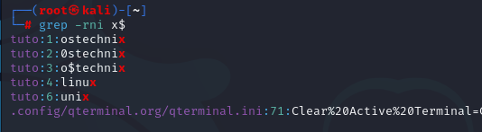

1. search for the words that contains the string "tech"



Or



1. search for the words that matches the pattern "tech" at the beginning of the line in a file



Or



1. search for the words that ends with a particular letter(s), for example "x"



Or



1. search for any word that has "n" in the file.

